|  |
| --- |
|  |



**Contact Worker Band 3**



###### NEW SHSCT Logo & Strapline - 20

**JOB DESCRIPTION**

|  |  |
| --- | --- |
|  |  |
| **JOB TITLE** | Contact Worker (Permanent) |
| **BAND** | 3 |
| **DIRECTORATE** | CYPS |
| **INITIAL LOCATION** | Trustwide – Brownlow HSS Centre Craigavon  Dromolane House Newry  Lisanally House Armagh |
| **REPORTS TO** | Contact & Family Support Service Co-ordinator |
| **ACCOUNTABLE TO** | Service Manager |

**JOB SUMMARY**

The post holder’s primary role is to provide support to qualified social workers in carrying out their responsibilities when working with children and their families.

These supports will primarily include assisting with practical arrangements to facilitate contact between children and their parents, transport of children and parents to contact, services and appointments arranged by the Trust; and other administrative supports within the office.

**KEY DUTIES / RESPONSIBILITIES**

1. To co-work and work in partnership with colleagues and other professionals when carrying out specified tasks under the direction and supervision of a social worker.
2. To assist with practical arrangements which will facilitate contact between parents and children who are subject of child protection procedures or Looked After by the Trust.
3. To transport children and parents to services and appointments arranged by the Trust.
4. To keep clear and concise records of their contact with children and their families.
5. To liaise closely with and provide feedback and regular up dates to, qualified social work colleagues, regarding contact between children and their parents.
6. To care for children within Trust premises when parents are attending appointments or meetings organised by the Trust.
7. To work within and adhere to Trust policies and procedures and in particular Child Protection Policies and Procedures.
8. To maintain and protect the dignity of service users ensuring confidentiality of all information held.
9. To maintain accurate detailed records in accordance with Trust policy and procedure.
10. To liaise with other professionals, carers and parents as appropriate.
11. To report to the Team Leader/qualified Social Worker any untoward events in relation to the child or parent during contact.
12. To attend all relevant meetings and contribute as necessary.
13. To participate fully in formal supervision as required.
14. To participate in training programmes when appropriate.
15. To comply with health and safety legislation and any other appropriate duties as may be allocated by the Team Leader.

**RAISING CONCERNS - RESPONSIBILITIES**

1. The post holder will promote and support effective team working, fostering a culture of openness and transparency.
2. The post holder will ensure that they take all concerns raised with them seriously and act in accordance with the Trust’s ‘Your Right to Raise a Concern (Whistleblowing)’ policy and their professional code of conduct, where applicable.

**GENERAL REQUIREMENTS**

The post holder will be required to:

1. Ensure the Trust’s policy on equality of opportunity is promoted through his/her own actions and those of any staff for whom he/she has responsibility.
2. Co-operate fully with the implementation of the Trust's Health and Safety arrangements, reporting any accidents/incidents/equipment defects to his/her manager, and maintaining a clean, uncluttered and safe environment for patients/clients, members of the public and staff.
3. Adhere at all times to all Trust policies/codes of conduct, including for example:
   * Smoke Free policy
   * IT Security Policy and Code of Conduct
   * standards of attendance, appearance and behaviour

1. Contribute to ensuring the highest standards of environmental cleanliness within your designated area of work.

1. Co-operate fully with regard to Trust policies and procedures relating to infection prevention and control.

1. All employees of the Trust are legally responsible for all records held, created or used as part of their business within the Trust including patients/clients, corporate and administrative records whether paper-based or electronic and also including emails. All such records are public records and are accessible to the general public, with limited exceptions, under the Freedom of Information Act 2000 the Environmental Information Regulations 2004, the General Data Protection Regulations (GDPR) and the Data Protection Act 2018. Employees are required to be conversant with the [org name] policy and procedures on records management and to seek advice if in doubt.
2. Take responsibility for his/her own ongoing learning and development, in order to maximise his/her potential and continue to meet the demands of the post.
3. Represent the Trust’s commitment to providing the highest possible standard of service to patients/clients and members of the public, by treating all those with whom he/she comes into contact in the course of work, in a pleasant, courteous and respectful manner.

This Job Description will be subject to review in the light of changing circumstances and is not intended to be rigid and inflexible but should be regarded as providing guidelines within which the individual works. Other duties of a similar nature and appropriate to the grade may be assigned from time to time.

It is a standard condition that all Trust staff may be required to serve at any location within the Trust's area, as needs of the service demand.

### NEW SHSCT Logo & Strapline - 20

### **PERSONNEL SPECIFICATION**

**JOB TITLE AND BAND Contact Worker Band 3**

**DEPARTMENT / DIRECTORATE CYPS**

**SALARY**

**HOURS 37.5 Permanent**

**Ref No:** <to be inserted by HR> **January 2021**

**Notes to applicants:**

1. *You must clearly demonstrate on your application form under each question, how you meet the required criteria as failure to do so may result in you not being shortlisted. You should clearly demonstrate this for both the essential and desirable criteria.*
2. *Shortlisting will be carried out on the basis of the essential criteria set out in Section 1 below, using the information provided by you on your application form. Please note the Trust reserves the right to use any desirable criteria outlined in Section 3 at shortlisting. You must clearly demonstrate on your application form how you meet the desirable criteria.*
3. *Proof of qualifications and/or professional registration will be required if an offer of employment is made – if you are unable to provide this, the offer may be withdrawn.*

|  |  |  |
| --- | --- | --- |
| **ESSENTIAL CRITERIA** | | |
| **SECTION 1:** The following are **ESSENTIAL** criteria which will initially be measured at shortlisting stage although may also be further explored during the interview/selection stage. You should therefore make it clear on your application form whether or not you meet these criteria. Failure to do so may result in you not being shortlisted. The stage in the process when the criteria will be measured is stated below. | | |
| **Factor** | **Criteria** | **Method of Assessment** |
| **Experience** | 6 months’ experience (either paid or voluntary) in a social care Setting; | Shortlisting by Application Form |
| **Qualifications/ Registration** | 4 GCSEs at Grades A-C including English Language or equivalent / higher qualification.  Currently hold, or be eligible for, registration with the Northern Ireland Social Care Council on the Social Care part of the register | Shortlisting by Application Form |
| **Other** | Hold a current full driving licence which is valid for use in the UK and have access to a car on appointment. *This criteria will be waived in the case of applicants whose disability prohibits driving but who have access to a form of transport approved by the Trust which will* *permit them to carry out the duties of the post.* | Shortlisting by Application Form |
| **SECTION 2**: The following are **ESSENTIAL** criteria which will be measured during the interview/ selection stage: | | |
| **Skills / Abilities** | 1. Effective communication skills to meet the needs of the post in full. 2. Ability to work as part of a team. 3. Ability to use own initiative. 4. Good organisation skills with an ability to prioritise own workload. | Interview |
| **Knowledge** | Knowledge of the social work process relevant to child care. | Interview |

|  |  |  |
| --- | --- | --- |
| **DESIRABLE CRITERIA** | | |
| **SECTION 3:** these will **ONLY** be used where it is necessary to introduce additional job related criteria to ensure files are manageable. You should therefore make it clear on your application form how you meet these criteria. Failure to do so may result in you not being shortlisted | | |
| **Factor** | **Criteria** | **Method of Assessment** |
| **Experience** | Experience of working with children and families | Shortlisting by Application Form |
| **Qualifications** |  | Shortlisting by Application Form |

**If this post is being sought on secondment then the individual MUST have the permission of their line manager IN ADVANCE of making application.**

*As part of the Recruitment & Selection process it may be necessary for the Trust to carry out an Enhanced Disclosure Check through Access NI before any appointment to this post can be confirmed.*

*Successful applicants may be required to attend for a Health Assessment*

**THE TRUST IS AN EQUAL OPPORTUNITIES EMPLOYER**

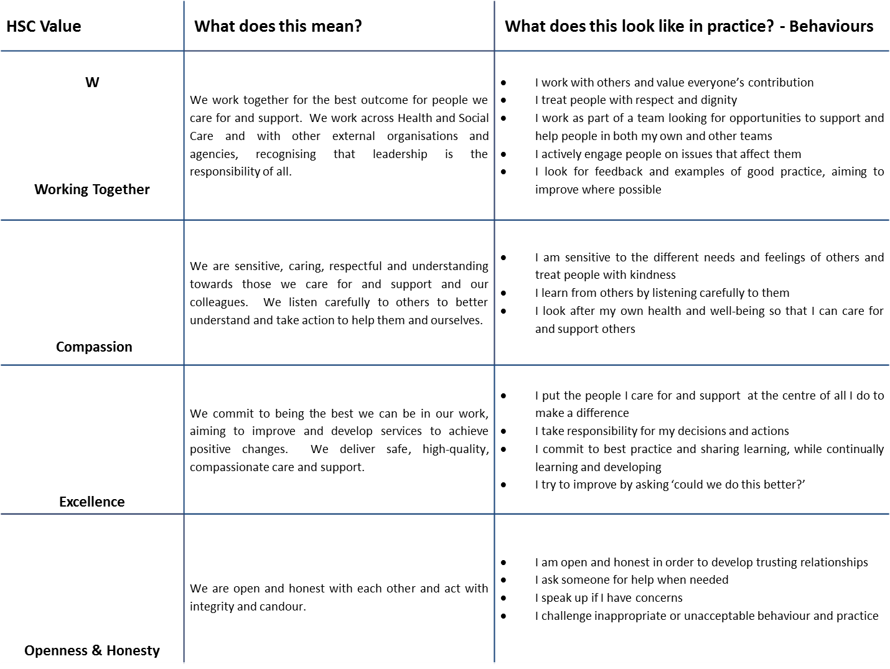

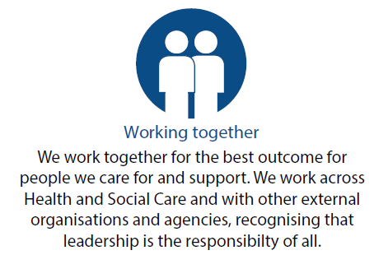

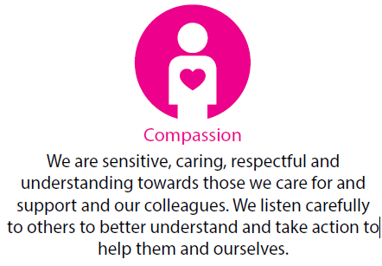





**All staff are expected to display the HSC Values at all times**

 

